 | SR UNIVERSITY  Campus Warangal
 | Program: II - B. Tech (CS& AI) Batch:
 | Name: K Pallavi Reg. No:2503A52356
 | Department: Computer Science and AI Semester: I
 | AI Assisted Coding-Assignment Date: 21-09-2026

- Question
- Prompt
- Code
- Output
- Observation

Task 1
Question:To understand and implement non-linear data structures using Python and AI-assisted coding. Students will apply Tree, Graph, Heap, and Trie structures to practical problems and justify their choices using Big-O complexity.
Prompt:Create a Python tree structure to represent a hospital department hierarchy. Implement adding child nodes, displaying the hierarchy, searching for a department, and counting nodes. Explain how a tree is different from a list and provide test cases.

Code:
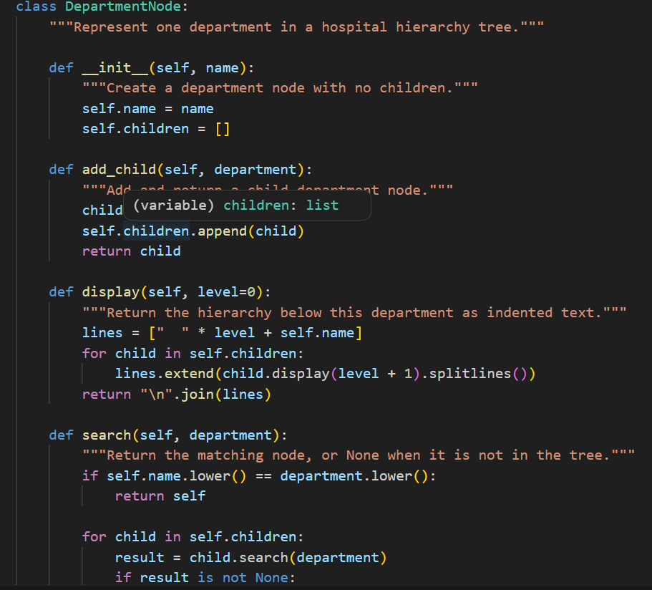

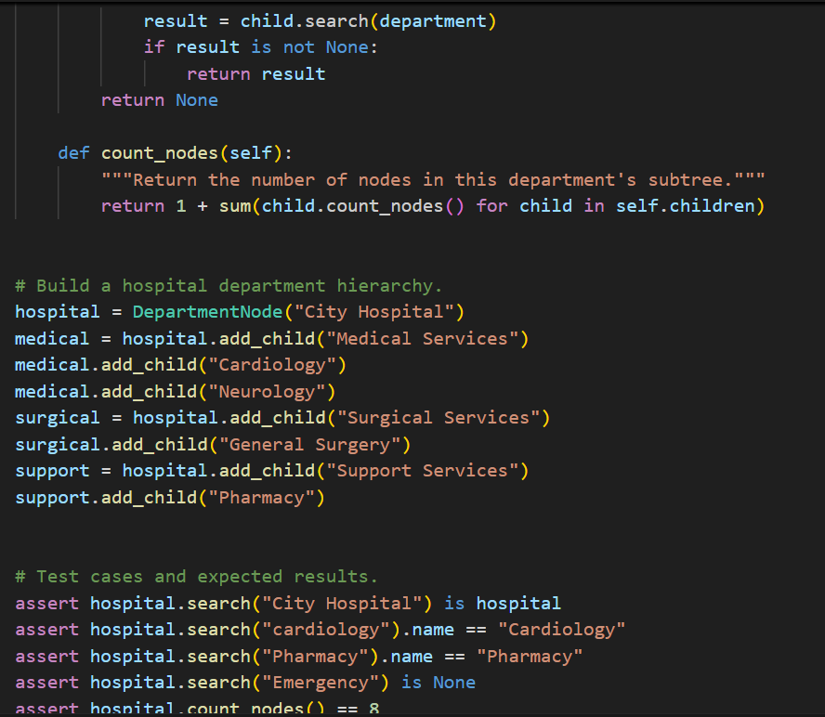

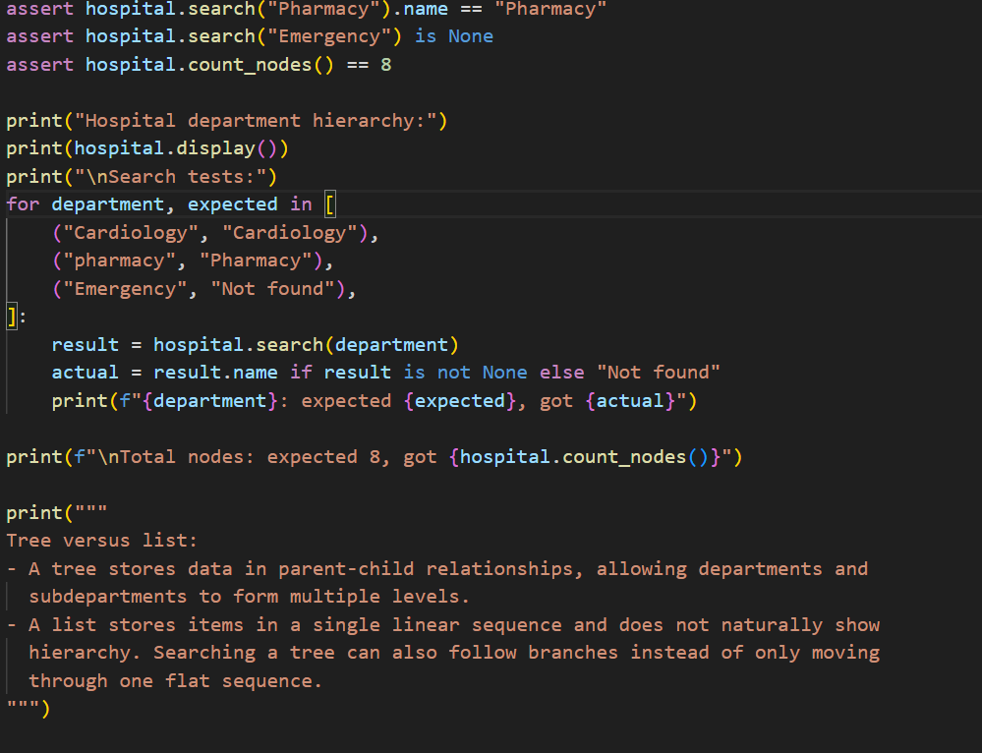

Output:
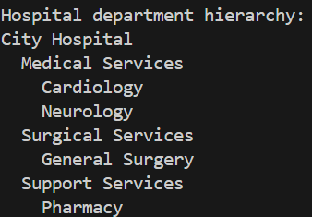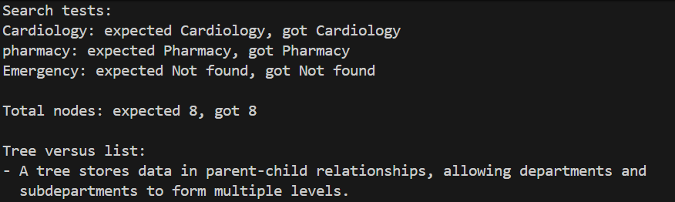
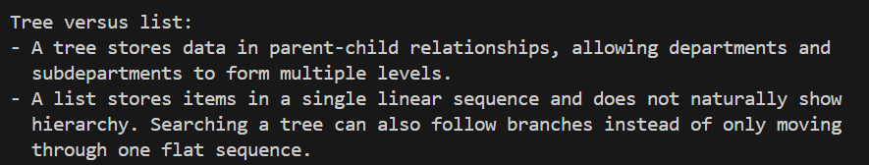
Observation:
The hospital locations were successfully represented using a graph and adjacency list. Nodes represented hospital locations, while edges represented direct routes between them. Breadth-First Search (BFS) found the shortest route between connected locations by exploring nearby locations level by level. The test cases confirmed direct routes, multi-step routes, same-location searches, and unavailable destinations. The program executed successfully without errors.

Task 2

Question
Represent hospital locations as a Graph. Each location is a node and each connection is an edge.
Prompt
Create a Python graph representing hospital locations. Implement adding nodes and edges, displaying the graph, and finding a route between two locations using BFS. Explain BFS step by step and provide test cases.
Code
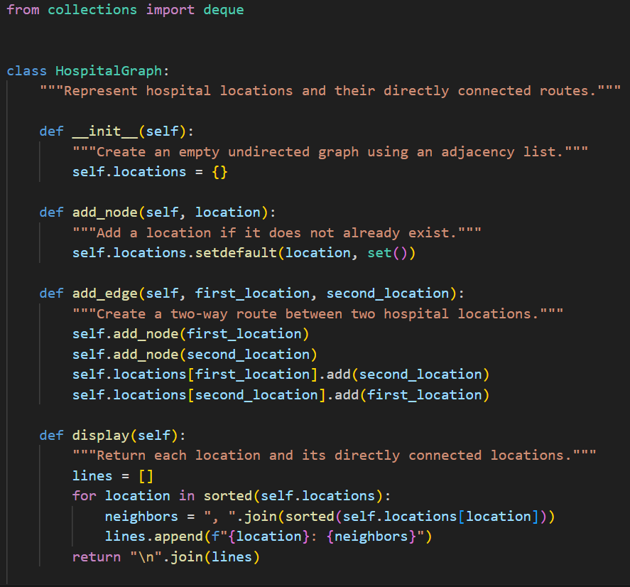
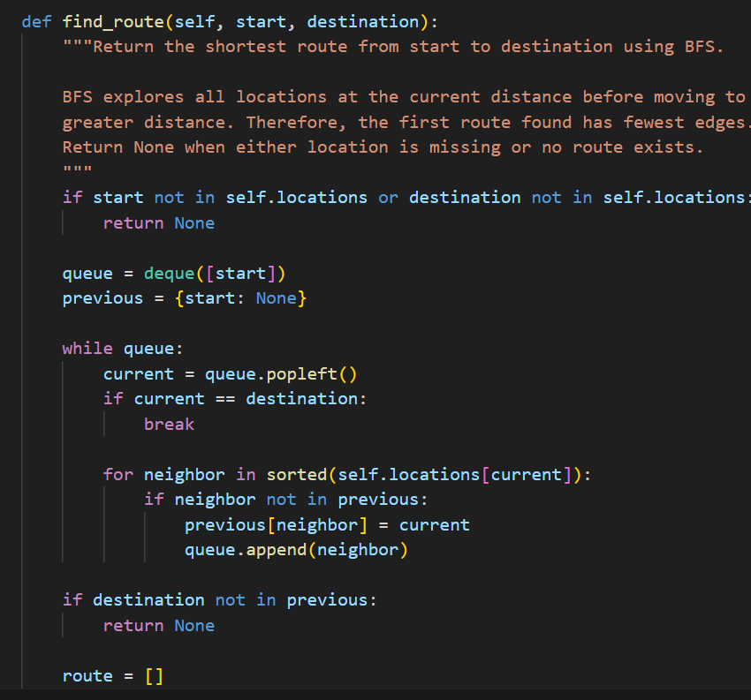
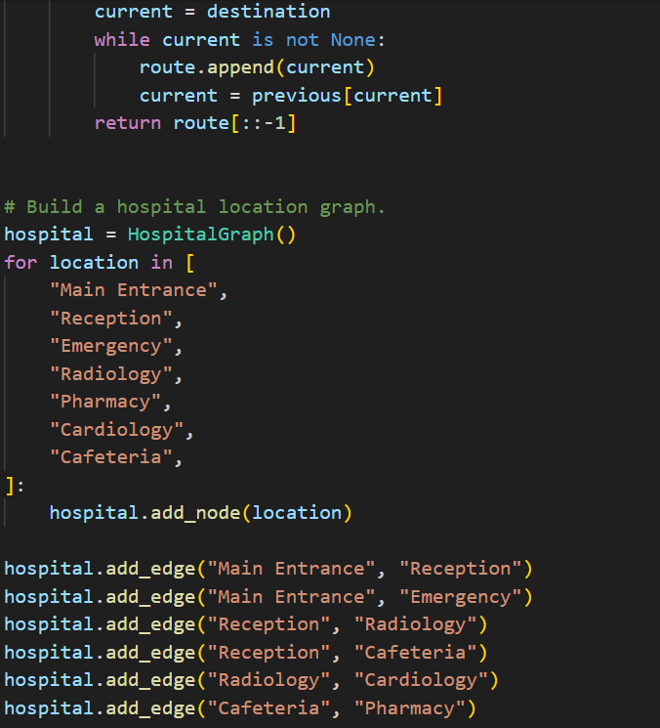

Output
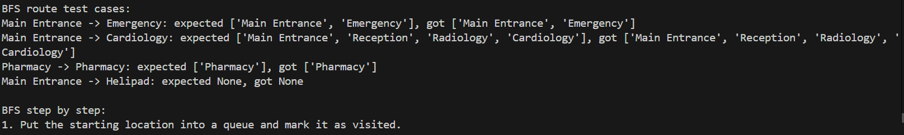
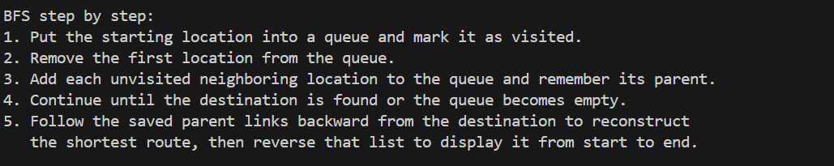
Observation
The Hospital Route Finder graph successfully represents hospital locations as nodes and their connections as edges. The adjacency list clearly shows which locations are directly connected. Using BFS, routes between different hospital locations can be found systematically by visiting nearby locations level by level.
Task 3
Question
In an emergency department, patients are treated according to severity rather than simple arrival order. Implement a Priority Queue using a Heap.
Prompt
Prompt:
Implement a priority queue using a heap to manage emergency patients.
Priority 1 is Critical, 2 is Serious, 3 is Moderate, and 4 is Normal.
The program must add patients, view and serve the highest-priority patient,
display the waiting list, handle equal priorities, and test insertion/removal.
Patients with the same priority are served in the order they were added.
"""
Code
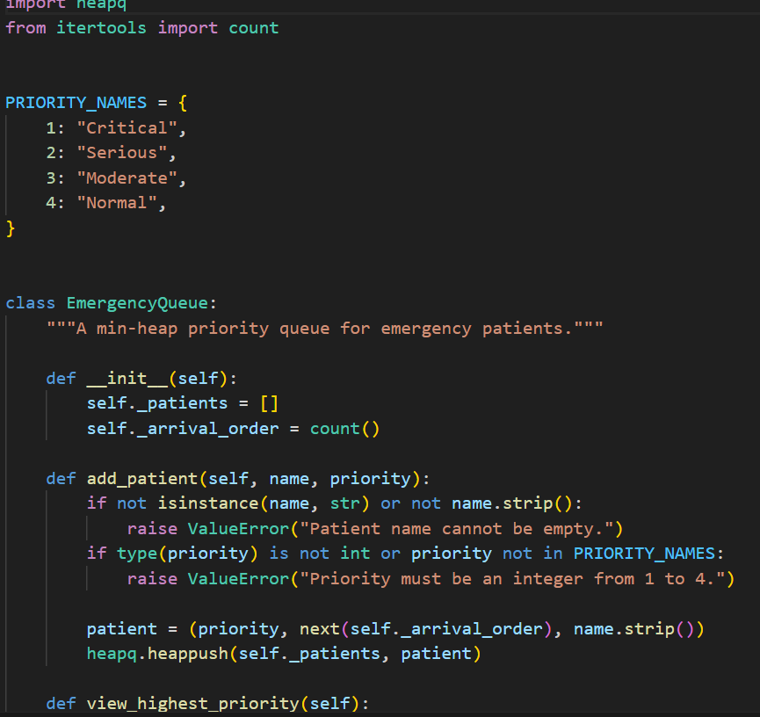
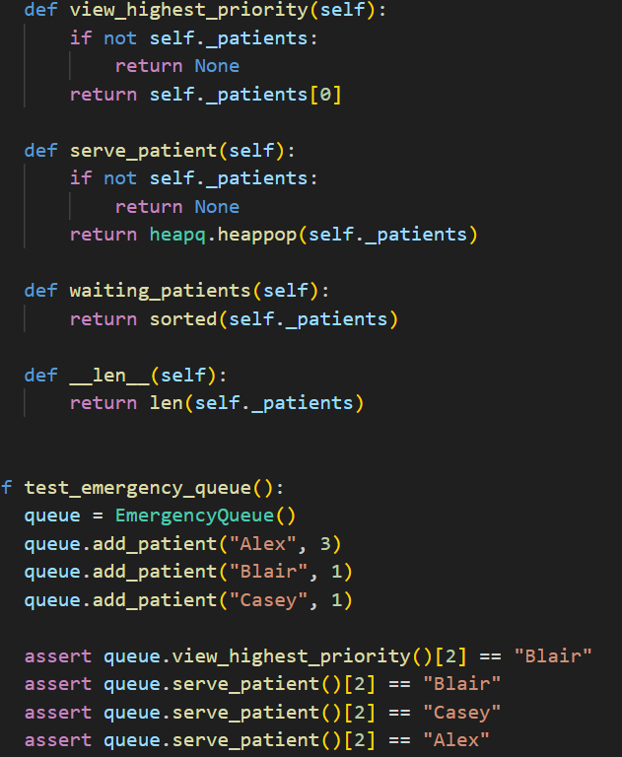
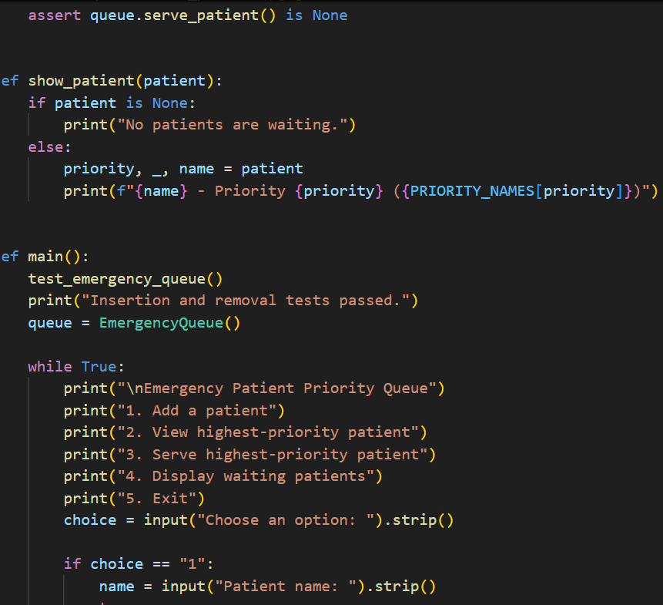
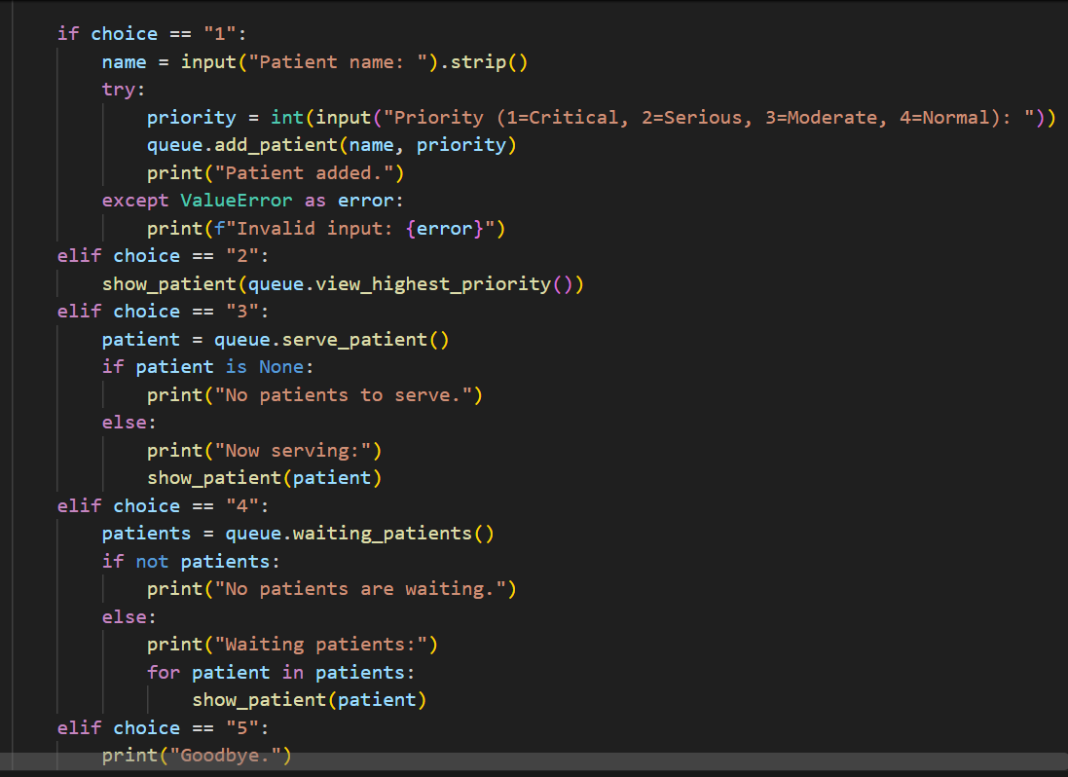
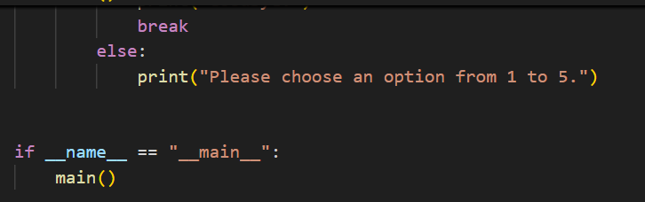
Output
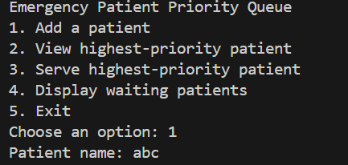
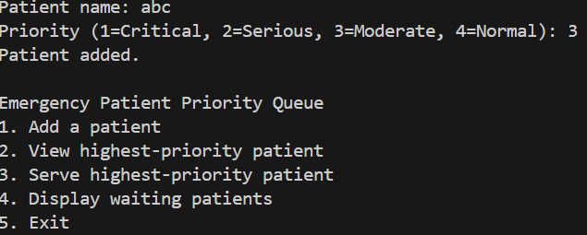
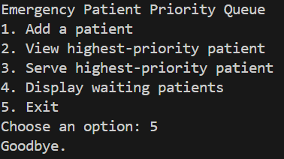
Observation
The Emergency Patient Priority Queue successfully manages patients according to the severity of their condition rather than their arrival order

Task 4
Question
A hospital application needs an auto complete feature. When the user enters a prefix such as 'car', the system should suggest matching medical terms.
Prompt
Implement a Trie in Python for medical-word autocomplete. Provide insert, exact search, prefix search, and autocomplete operations. Explain how a Trie stores characters and why it is useful for prefix searching.
Code
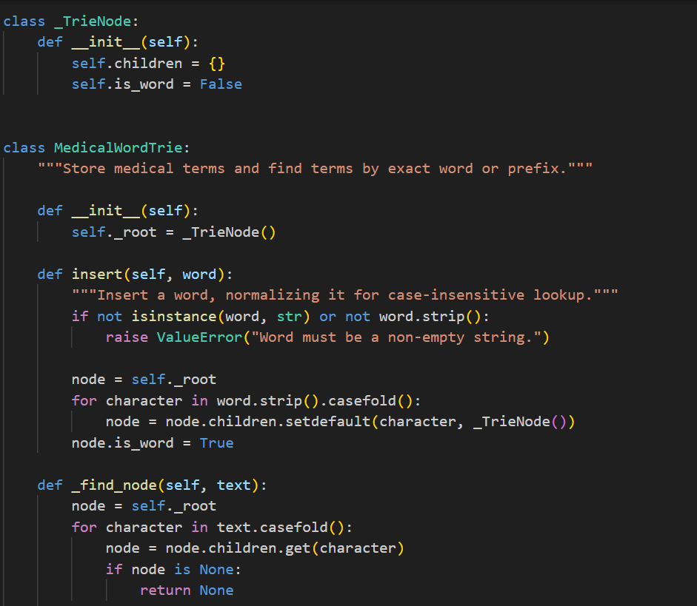
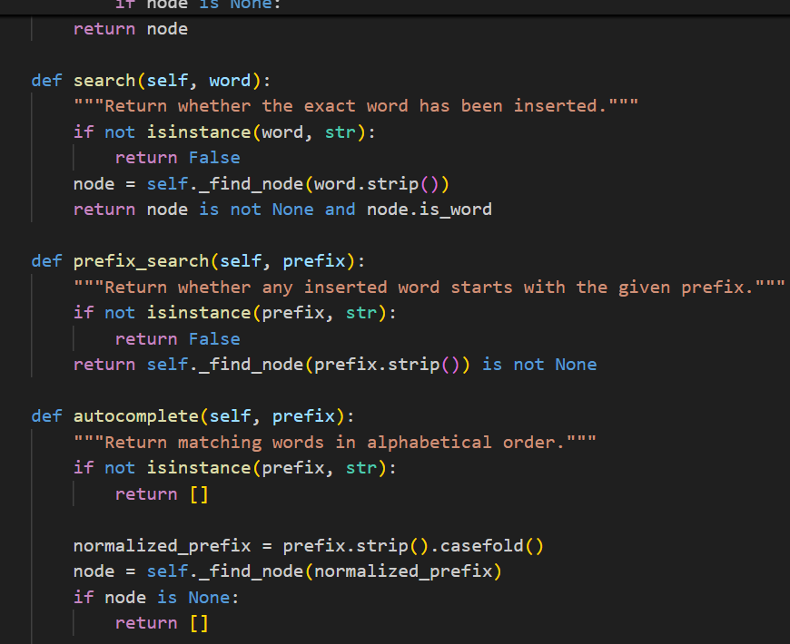
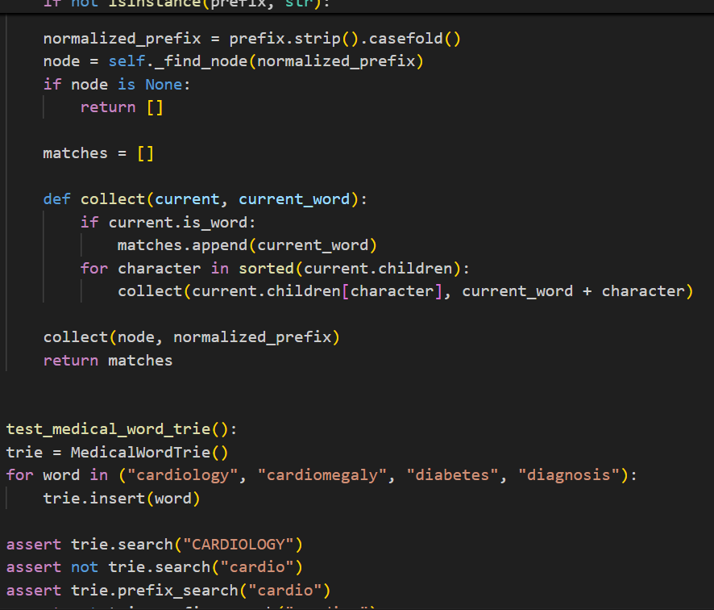
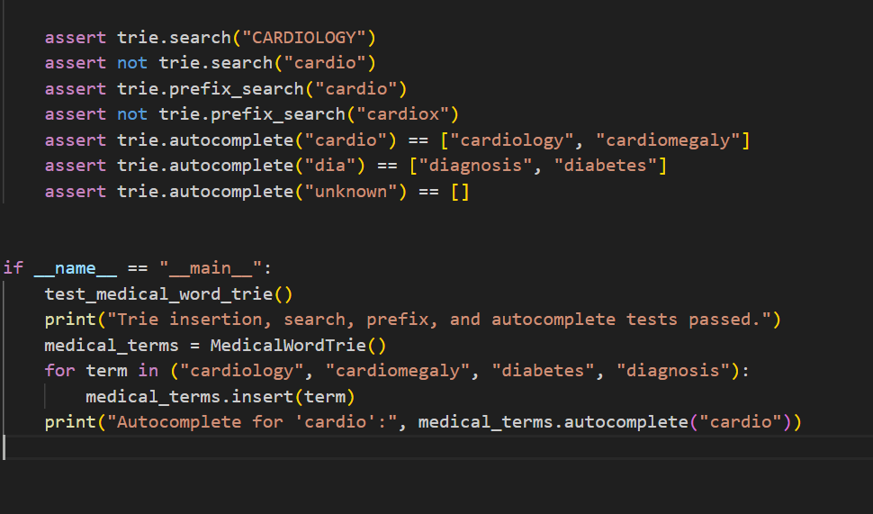
Output
Observation
The Trie provides efficient search, prefix checking, and auto complete operations. It is especially useful in hospital applications for quickly suggesting medical terms or drug names as the user types.
Task 5
Question
For each hospital-software scenario, choose the most appropriate non-linear data structure: Tree, Graph, Heap, or Trie.
Prompt
For route finding,BFS applies when every connection has equal cost; use Dijkstra’s algorithm when routes have different distances or travel times
Code
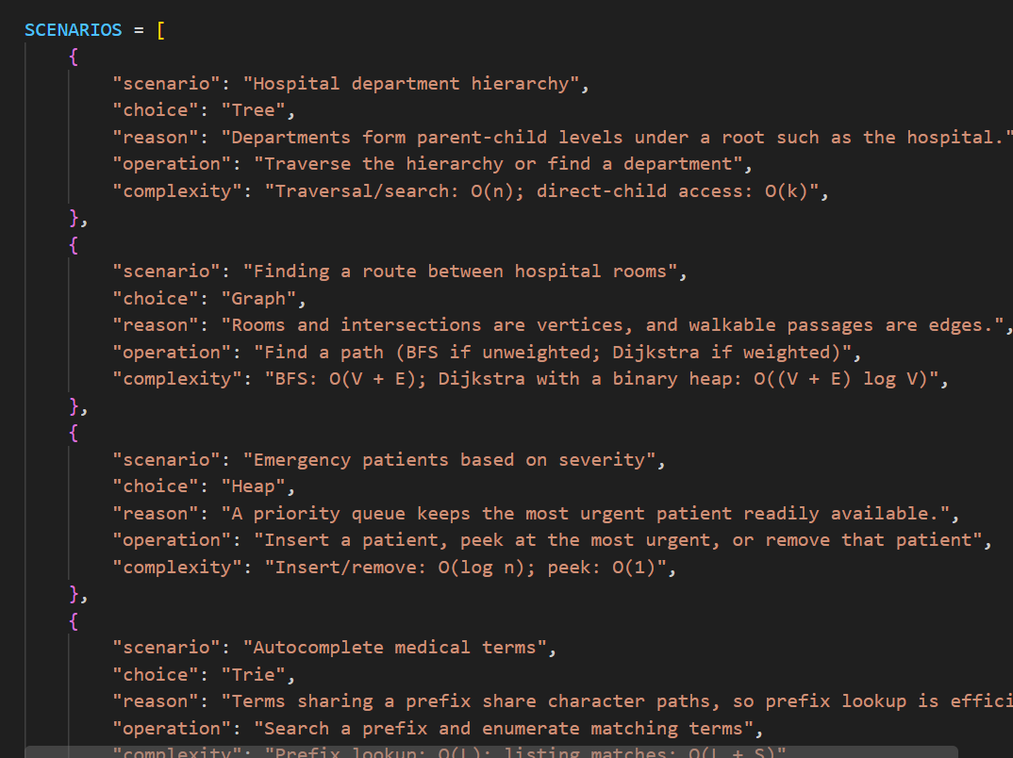
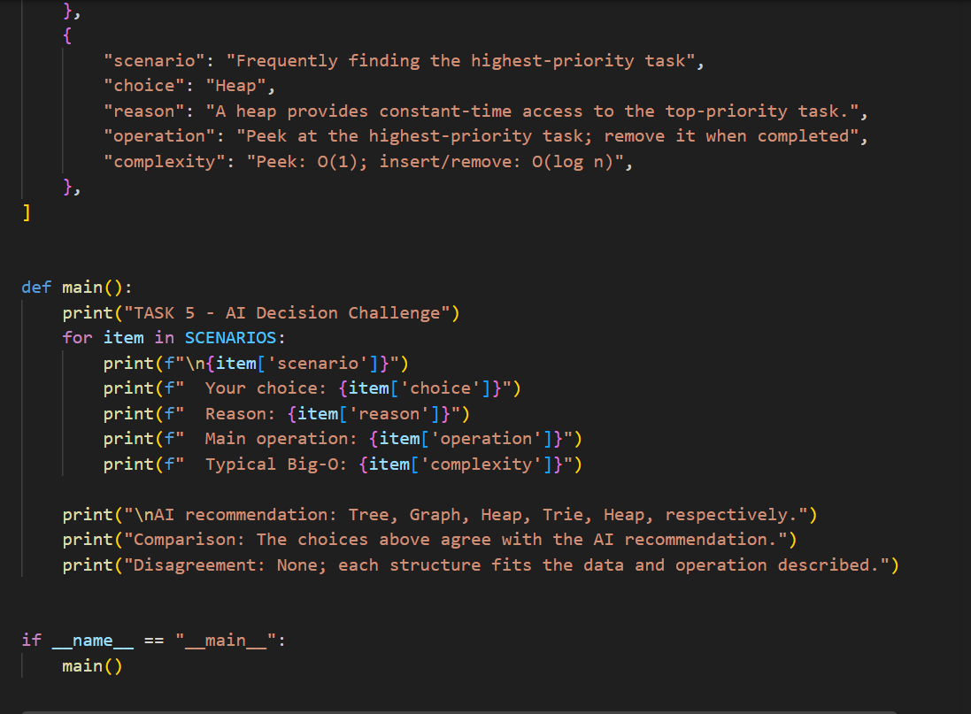
Output
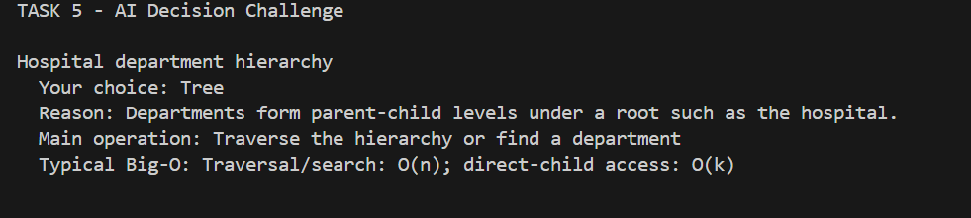
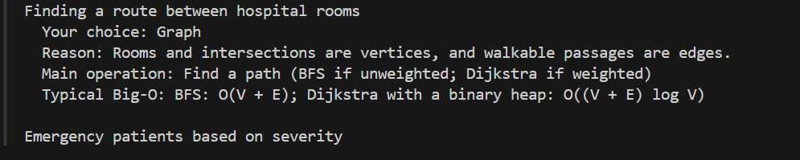
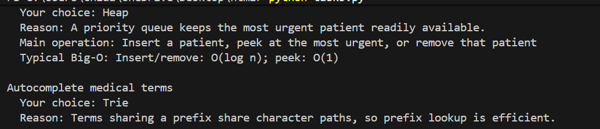
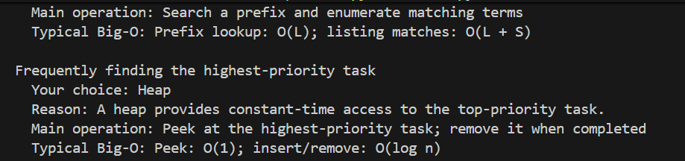
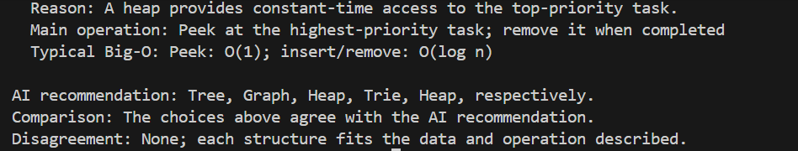
Observation
The appropriate non-linear data structure depends on the type of relationship or operation required. Trees are best for hierarchical relationships, Graphs for networks and routes, Heaps for priority-based processing, and Tries for prefix-based word searching. The AI recommendations matched my choices for all five hospital scenarios. Therefore, I agree with the AI recommendations.

